Lab Script

Example:

Go to <https://climate.esa.int/en/odp/#/dashboard>

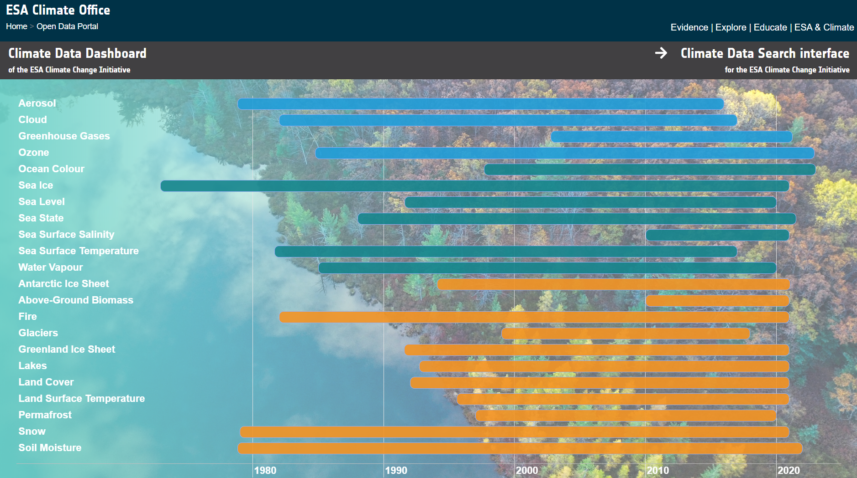

Different variables: This example will use Sea Surface Salinity

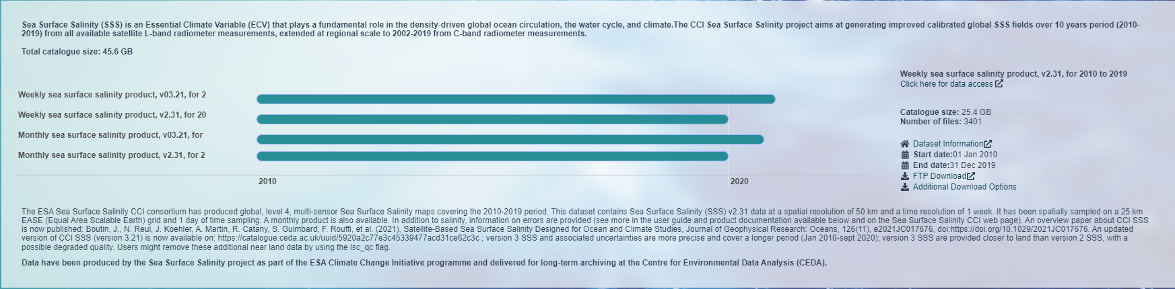

Click on the product you want to use, then click on “dataset information” on the right

Products, each has slightly different datasets, so make sure to read the description for each. This example will use monthly v03.21. Generally newer “v”s (versions) are better

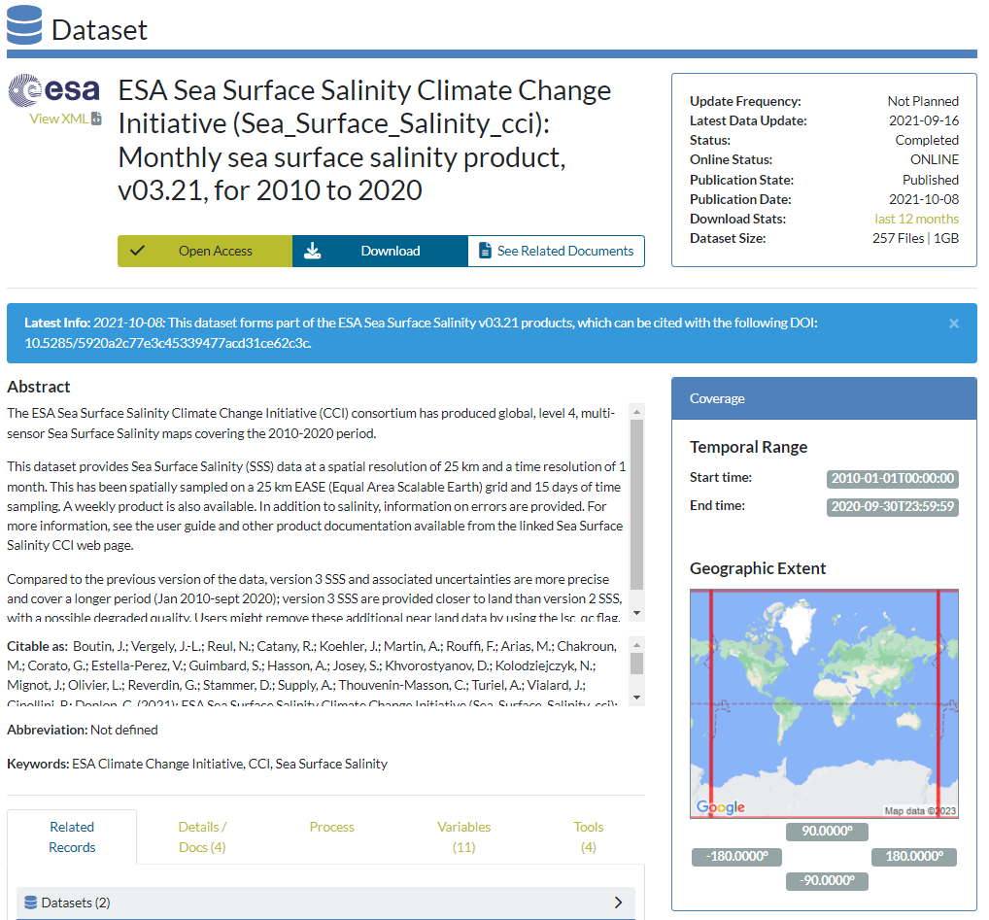

Important bits. Use the “Variables” menu to see what each variable will be before downloading the data. This example will use the “Multi-Satellite Sea Surface Salinity” (sss)

When you’ve had a glance at all this, click on the “download” button at the top

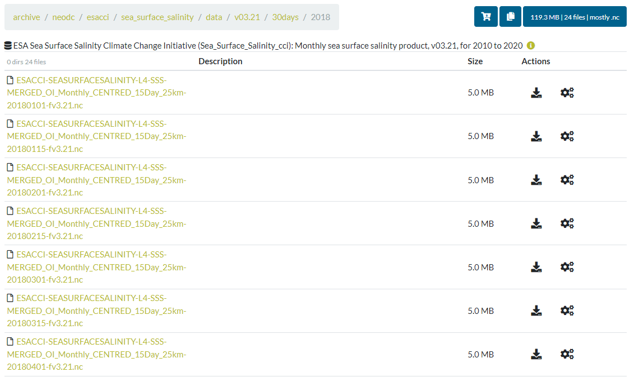

There is the option here to download all the files, only do this if you’re sure about it. ALWAYS CHECK THE FILE SIZES. These are nice and small, but they can get up to 1GB per file for some.

The file names will say their date and all necessary information in them, for example the top one’s date is “2018/01/01”. You can download individual files by clicking the download symbol, next to the size of each file.

When working with lots of data with similar names, like these, make sure you have a good file organisation system. Keep the datasets separate if you end up using more than one.

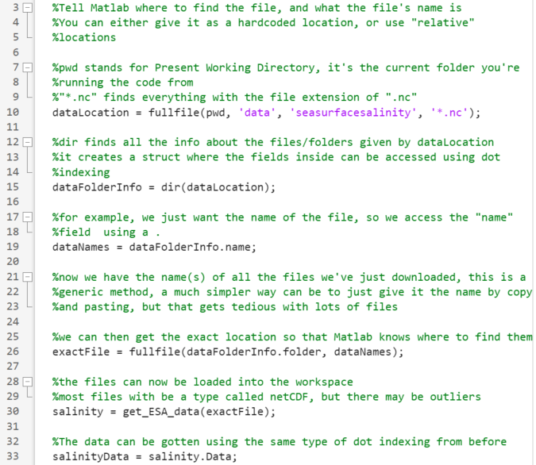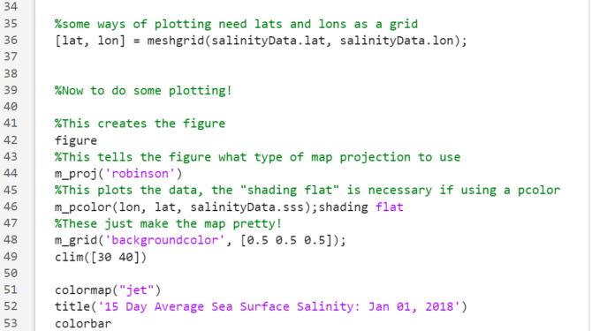

Running this code will produce this image:

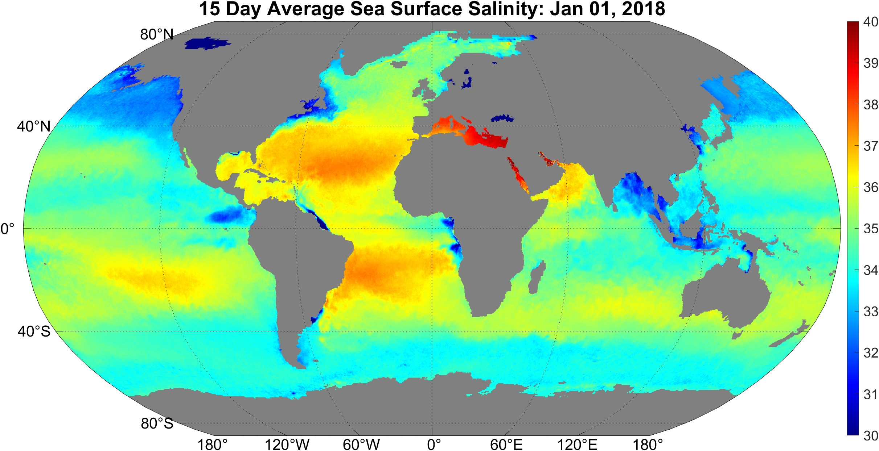

This is already interesting to look at, for instance over the Mediterranean and Bangladesh, but more science can be done. Time series analysis can happen